**Unit-III**

**DC GENERATORS &DC MOTORS**

**Principle of Operation of a D.C. Generator**

All the generators work on a principle of dynamically induced e.m.f. This principle nothing but the Faraday’s law of electromagnetism induction.

It states that, ‘whenever the number of magnetic lines of force i.e. flux linking with a conductor or a coil changes, an electromotive force is set up in that conductor or coil.’

The change in flux associated with the conductor can exist only when there exists a relative motion between a conductor and the flux. The relative motion can be achieved by rotating conductor with respect to flux or by rotating flux with respect to a conductor. So a voltage gets generated in a conductor, as long as there exists a relative motion between conductor and the flux.

Such an induced e.m.f. which is due to the physical movement of coil or conductor with respect to flux or movement of flux with respect to coil or conductor is called dynamically induced e.m.f.

### Key Point:

So a generating action requires following basic components to exist,

1. The conductor or a coil
2. The relative motion between conductor and flux.

In a particular generator, the conductors are rotated to cut the magnetic flux, keeping flux stationary. To have a large voltage as the output, the number of conductors are connected together in a specific manner, to form a winding. This winding is called armature winding of a d.c. machine. The part on which this winding is kept is called armature of a d.c. machine. To have the rotation of conductors, the conductors placed on the armature are rotated with the help of some external device. Such an external device is called a prim mover. The commonly used prim movers are diesel engines, steam engines, steam turbines, water turbines etc. The necessary magnetic flux is produced by current carrying winding which is called field winding. The direction of the induced e.m.f. can be obtained by using [Fleming’s right hand role.](https://electricallive.com/2015/03/principle-of-operation-of-dc-generator.html)

# Single Loop DC Generator

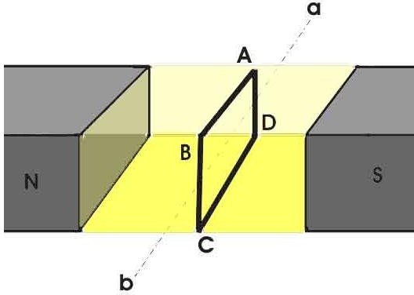

## Figure: Single Loop Generator

In the figure above, a single loop of conductor of rectangular shape is placed between two opposite poles of magnet.

Let's us consider, the rectangular loop of conductor is ABCD which rotates inside the magnetic field about its own axis ab. When the loop rotates from its vertical position to its horizontal position, it cuts the [flux](https://www.electrical4u.com/what-is-flux-types-of-flux/) lines of the field. As during this movement two sides, i.e. AB and CD of the loop cut the flux lines there will be an emf induced in these both of the sides (AB and BC) of the loop.

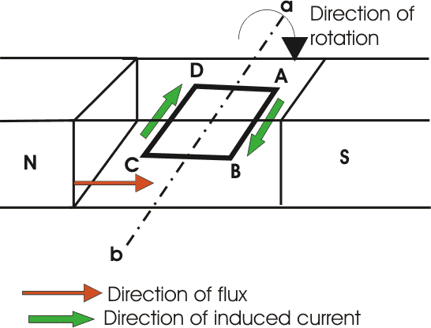

## Figure: Single Loop Generator

As the loop is closed there will be a current circulating through the loop. The direction of the current can be determined by [Fleming’s right hand Rule.](https://www.electrical4u.com/fleming-left-hand-rule-and-fleming-right-hand-rule/) This rule says that if you stretch thumb, index finger and middle finger of your right hand perpendicular to each other, then thumbs indicates the direction of motion of the [conductor,](https://www.electrical4u.com/electrical-conductor/) index finger indicates the direction of [magnetic field](https://www.electrical4u.com/magnetic-field/) i.e. N - pole to S - pole, and middle finger indicates the direction of flow of current through the conductor.

Now if we apply this right-hand rule, we will see at this horizontal position of the loop, current will flow from point A to B and on the other side of the loop current will flow from point C to D.

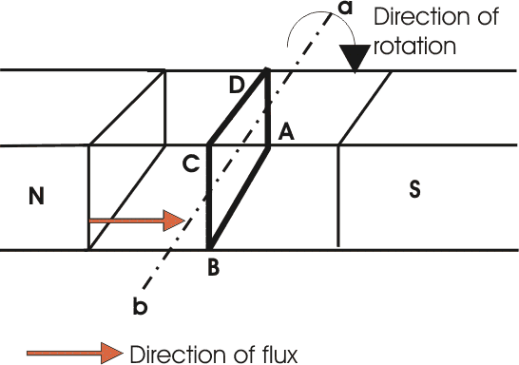

## Figure: Single Loop Generator

Now if we allow the loop to move further, it will come again to its vertical position, but now upper side of the loop will be CD and lower side will be AB (just opposite of the previous vertical position). At this position the tangential motion of the sides of the loop is parallel to the flux lines of the field. Hence there will be no question of flux cutting and consequently there will be no current in the loop. If the loop rotates further, it comes to again in horizontal position. But now, said AB side of the loop comes in front of N pole and CD comes in front of S pole, i.e. just opposite to the previous horizontal position as shown in the figure beside.

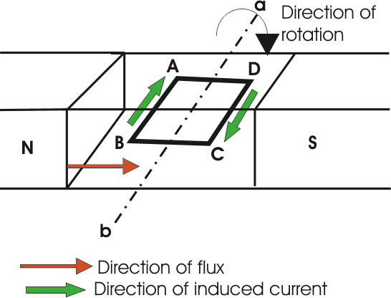

## Figure: Single Loop Generator

Here the tangential motion of the side of the loop is perpendicular to the flux lines, hence rate of flux cutting is maximum here and according to [Fleming’s right hand Rule](https://www.electrical4u.com/fleming-left-hand-rule-and-fleming-right-hand-rule/), at this position current flows from B to A and on other side from D to C. Now if the loop is continued to rotate about its axis, every time the side AB comes in front of S pole, the current flows from A to B and when it comes in front of N pole, the current flows from B to A. Similarly, every time the side CD comes in front of S pole the current flows from C to D and when it comes in front of N pole the current flows from D to C.

If we observe this phenomena in different way, it can be concluded, that each side of the loop comes in front of N pole, the current will flow through that side in same direction i.e. downward to the reference plane and similarly each side of the loop comes in front of S pole, current through it flows in same direction i.e. upwards from reference plane. From this, we will come to the topic of principle of DC generator. Now the loop is opened and connected it with a split ring as shown in the figure below. Split ring are made out of a conducting cylinder which cuts into two halves or segments insulated from each other. The external load terminals are connected with two carbon brushes which are rest on these split slip ring segments.

# Working Principle of DC Generator

Fig: Commutation action

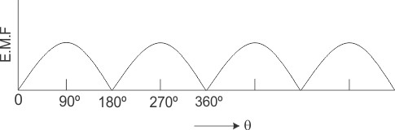It is seen that in the first half of the revolution current flows always along ABLMCD i.e. brush no 1 in contact with segment a. In the next half revolution, in the figure the direction of the induced current in the coil is reversed. But at the same time the position of the segments a and b are also reversed which results that brush no 1 comes in touch with the segment b. Hence, the current in the load [resistance](https://www.electrical4u.com/electrical-resistance-and-laws-of-resistance/) again flows from L to M. The wave from of the current through the load circuit is as shown in the figure. This current is unidirectional.

Fig: Output waveform of generator

This is basic working principle of DC generator, explained by single loop generator model. The position of the [brushes of DC generator](https://www.electrical4u.com/construction-of-dc-generator-yoke-pole-armature-brushes-of-dc-generator/) is so arranged that the change over of the segments a and b from one brush to other takes place when the plane of rotating coil is at right angle to the plane of the lines of force. It is so become in that position, the induced emf in the coil is zero.

# Construction of a DC Machine:

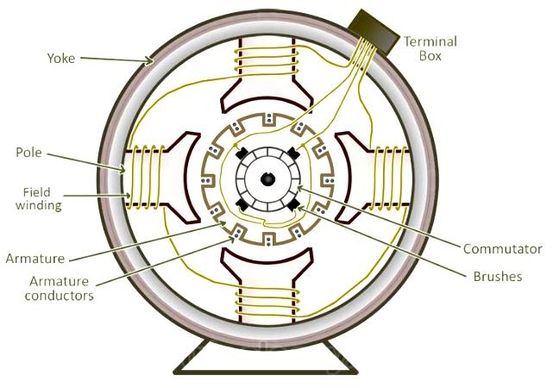A DC generator can be used as a DC motor without any constructional changes and vice versa is also possible. Thus, a DC generator or a [DC motor](https://www.electricaleasy.com/2014/01/basic-working-of-dc-motor.html) can be broadly termed as a DC machine. These basic constructional details are also valid for the construction of a DC motor. Hence, let's call this point as construction of a DC machine instead of just 'construction of a DC generator.

Figure 1: constructional details of a simple 4-pole DC machine

The above figure shows constructional details of a simple 4-pole DC machine. A DC machine consists of two basic parts; stator and rotor. Basic constructional parts of a DC machine are described below.

* 1. **Yoke:** The outer frame of a dc machine is called as yoke. It is made up of cast iron or steel. It not only provides mechanical strength to the whole assembly but also carries the magnetic flux produced by the field winding.
  2. 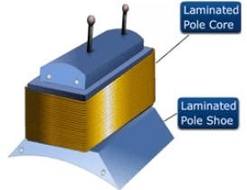**Poles and pole shoes:** Poles are joined to the yoke with the help of bolts or welding. They carry field winding and pole shoes are fastened to them. Pole shoes serve two purposes; (i) they support field coils and (ii) spread out the flux in air gap uniformly.

Figure 2: Pole Core and Poles Shoes representation

* 1. **Field winding:** They are usually made of copper. Field coils are former wound and placed on each pole and are connected in series. They are wound in such a way that, when energized, they form alternate North and South poles.
  2. **Armature core:** Armature core is the rotor of a dc machine. It is cylindrical in shape with slots to carry armature winding. The armature is built up of thin laminated circular steel disks for reducing eddy current losses. It may be provided with air ducts for the axial air flow for cooling purposes. Armature is keyed to the shaft.

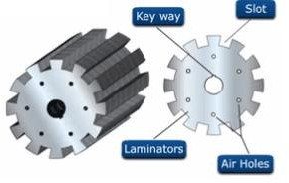

Figure 3: Armature of DC machine

* 1. [**Armature winding**](https://www.electricaleasy.com/2012/12/armature-winding-of-dc-machine.html)**:** It is usually a former wound copper coil which rests in armature slots. The armature conductors are insulated from each other and also from the armature core. Armature winding can be wound by one of the two methods; lap winding or wave winding. Double layer lap or wave windings are generally used. A double layer winding means that each armature slot will carry two different coils.

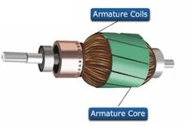

Figure 4: Armature Winding/coil of DC machine

* 1. **Commutator and brushes:** Physical connection to the armature winding is made through a commutator-brush arrangement. The function of a commutator, in a dc generator, is to collect the current generated in armature conductors. Whereas, in case of a dc motor, commutator helps in providing current to the armature conductors. A commutator consists of a set of copper segments which are insulated from each other. The number of segments is equal to the number of armature coils. Each segment is connected to an armature coil and the commutator is keyed to the shaft. Brushes are usually made from carbon or graphite. They rest on commutator segments and slide on the segments when the commutator rotates keeping the physical contact to collect or supply the current.

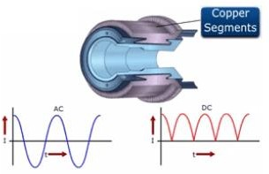

Figure 5: Commutator of DC machine

# Emf Equation of a DC Generator

As the armature rotates, a voltage is generated in its coils. In the case of a generator, the emf of rotation is called the Generated emf or Armature emf and is denoted as Er = Eg. In the case of a motor, the emf of rotation is known as Back emf or Counter emf and represented as Er = Eb. The expression for emf is same for both the operations. I.e., for Generator as well as for Motor

### Derivation of EMF Equation of a DC Machine – Generator and Motor

Let,

* + **P** – Number of poles of the machine
  + **ϕ** – Flux per pole in Weber.
  + **Z** – Total number of armature conductors.
  + **N** – Speed of armature in revolution per minute (r.p.m).
  + **A** – Number of parallel paths in the armature winding.

In one revolution of the armature, the flux cut by one conductor is given as

https://circuitglobe.com/wp-content/uploads/2015/11/EMF-EQUATION-OD-DC-GENERATOR-EQ1-compressor.jpgTime taken to complete one revolution is given as

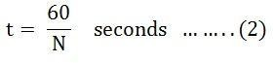 Therefore, the average induced e.m.f. in one conductor will be

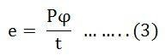Putting the value of (t) from Equation (2) in the equation (3) we will get

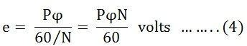

The number of conductors connected in series in each parallel path = Z/A.

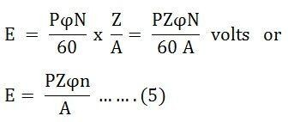Therefore, the average induced e.m.f across each parallel path or the armature terminals is given by the equation shown below.

Where n is the speed in revolution per second (r.p.s) and given as

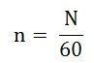For a given machine, the number of poles and the number of conductors per parallel path (Z/A) are constant. Hence, the equation (5) can be written as

EMF-EQUATION-OF-DC-GENERATOR-EQ7Where, K is a constant and given as

EMF-EQUATION-OF-DC-GENERATOR-EQ8

Therefore, the average induced emf equation can also be written as

EMF-EQUATION-OF-DC-GENERATOR-EQ11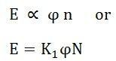Where K1 is another constant and hence induced emf equation can be written as

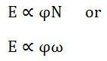

Where ω is the angular velocity in radians/second is represented as

Thus, it is clear that the induced emf is directly proportional to the speed and flux per pole. The polarity of induced emf depends upon the direction of the magnetic field and the direction of rotation. If either of the two is reverse the polarity changes, but if two are reversed the polarity remains unchanged.

This induced emf is a fundamental phenomenon for all the DC Machines whether they are working as a generator or motor.

If the machine DC Machine is working as a Generator, the induced emf is given by the equation shown below.

EMF-EQUATION-OF-DC-GENERATOR-EQ12

Where **Eg** is the **Generated Emf**

If the machine DC Machine is working as a Motor, the induced emf is given by the equation shown below.

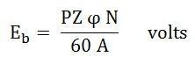

In a motor, the induced emf is called **Back Emf (Eb)** because it acts opposite to the supply voltage.

# Types of DC Generators – Separately Excited and Self Excited

The DC generator converts the electrical power into electrical power. The magnetic flux in a DC machine is produced by the field coils carrying current. The circulating current in the field windings produces a magnetic flux, and the phenomenon is known as Excitation. DC Generator is classified according to the methods of their field excitation.

By excitation, the DC Generators are classified as

1. Separately excited DC Generators
2. Self-excited DC Generators.
3. Permanent magnet type DC generators.

The self-excited DC Generators are further classified as

1. Shunt wound DC generators;
2. Series wound DC generators and
3. Compound wound DC generators.
4. Long shunt wound DC generators,
5. Short shunt wound DC generators.

The field pole of the DC generator is stationary, and the armature conductor rotates. The voltage generated in the armature conductor is of alternating nature, and this voltage is converted into the direct voltage at the brushes with the help of the commutator.

The detailed description of the various types of generators is explained below.

### Permanent Magnet type DC Generator

In this type of DC generator, there is no field winding is placed around the poles. The field produced by the poles of these machines remains constant. Although these machines are very compact but are used only in small sizes like dynamos in motorcycles, etc. The main disadvantage of these machines is that the flux produced by the magnets deteriorates with the passage of time which changes the characteristics of the machine.

### Separately Excited DC Generator

A DC generator whose field winding or coil is energized by a separate or external DC source is called a separately excited DC Generator. The flux produced by the poles depends upon the field current with the unsaturated region of magnetic material of the poles. i.e. flux is directly proportional to the field current. But in the saturated region, the flux remains constant.

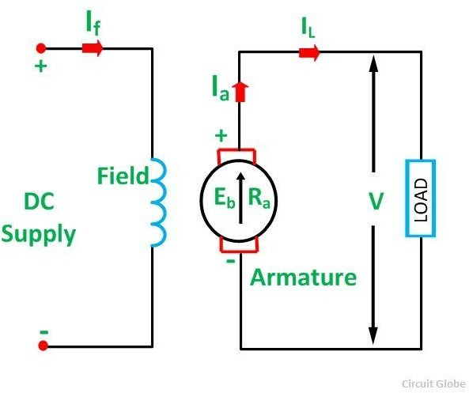The figure of self-excited DC Generator is shown below.

*Separately Excited DC Generator*

Here,

Ia = IL where Ia is the armature current and IL is the line current. Terminal voltage is given as

types-of-DC-generator-eq1-compressorIf the contact brush drop is known, then the equation (1) is written as

types-of-DC-generator-eq2The power developed is given by the equation shown below.

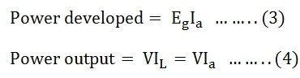

Power output is given by the equation (4) shown above.

### Self-Excited DC Generator

Self-excited **DC Generator** is a device, in which the current to the field winding is supplied by the generator itself. In self-excited DC generator, the field coils mat be connected in parallel with the armature in the series, or it may be connected partly in series and partly in parallel with the armature windings.

### The self-excited DC Generator is further classified as

1. Shunt Wound Generator
2. Series Wound Generator
3. Compound Wound Generator

### Shunt Wound Generator

In a **shunt wound generator,** the field winding is connected across the armature winding forming a parallel or shunt circuit. Therefore, full terminal voltage is applied across it. A very small field current Ish, flows through it because this winding has many turns of fine wire having very high resistance Rshof the order of 100 ohms.

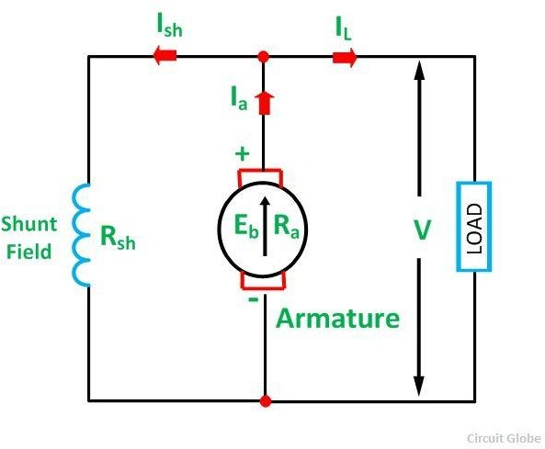The connection diagram of shunt wound generator is shown below.

*Shunt Wound DC Generator*

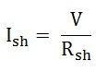Shunt field current is given as

Where Rsh is the shunt field winding resistance.

The current field Ish is practically constant at all loads. Therefore, the DC shunt machine is considered to be a constant flux machine.

types-of-DC-generator-eq5Armature current is given as

Terminal voltage is given by the equation shown below.

types-of-DC-generator-eq6

If the brush contact drop is included, the equation of the terminal voltage becomes

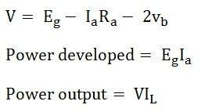

### Series Wound Generator

A **series-wound generator** the field coils are connected in series with the armature winding. The series field winding carries the armature current. The series field winding consists of a few turns of wire of thick wire of larger cross-sectional area and having low resistance usually of the order of less than 1 ohm because the armature current has a very large value.

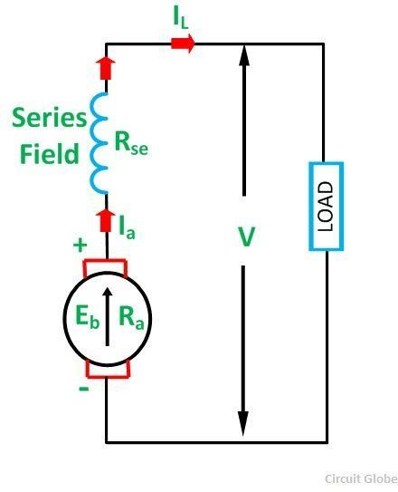Its convectional diagram is shown below.

*Series Wound DC Generator*

Series field current is given as

types-of-DC-generator-eq8

Rse is known as the series field winding resistance. Terminal voltage is given as

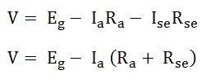

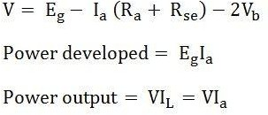If the brush contact drop is included, the terminal voltage equation is written as

The flux developed by the series field winding is directly proportional to the current flowing through I t. But it is only true before magnetic saturation after the saturation flux becomes constant even if the current flowing through it is increased.

### Compound Wound Generator

In a Compound Wound Generator, there are two sets of the field winding on each pole. One of them is connected in series having few turns of thick wire, and the other is connected in parallel having many turns of fine wire with the armature windings. In other words, the generator which has both shunt and series fields is called the compound wound generators.

* If the magnetic flux produced by the series winding assists the flux produced by the shunt winding, then the machine is said to be **cumulative compounded**.
* If the series field flux opposes the shunt field flux, then the machine is called the **differentially compounded**.

It is connected in two ways. One is a long shunt compound generator, and another is a short shunt compound generator. If the shunt field is connected in parallel with the armature alone then the machine is called the short compound generator. In long shunt compound generator, the shunt field is connected in series with the armature. The two types of generators are discussed below in details.

### Long Shunt Compound Wound Generator

In a long shunt wound generator, the shunt field winding is parallel with both armature and series field winding. The connection diagram of long shunt wound generator is shown below.

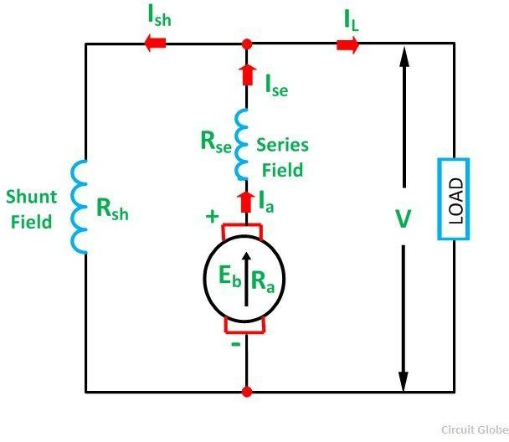

*Long Shunt Compound Wound Generator*

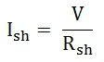Shunt field current is given as

Series field current is given as

https://circuitglobe.com/wp-content/uploads/2015/11/compound-wound-generator-eq2-compressor.jpgTerminal voltage is given as

ound-wound-generator-eq3If the brush contact drop is included, the terminal voltage equation is written as

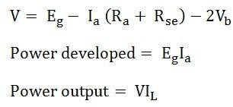Short Shunt Compound Wound Generator

In a Short Shunt Compound Wound Generator, the shunt field winding is connected in parallel with the armature winding only. The connection diagram of short shunt wound generator is shown below.

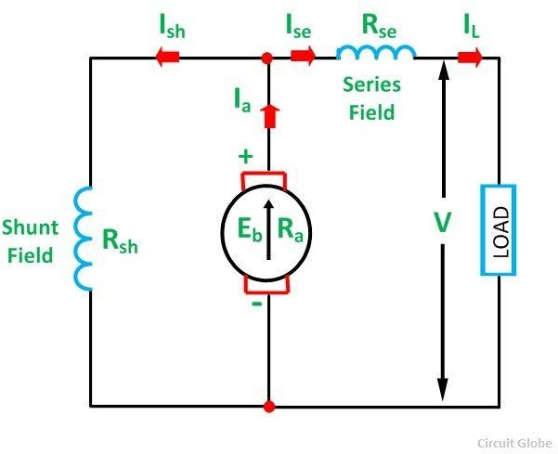

*Short Shunt Compound Wound Generator*

Series field current is given as

compound-wound-generator-eq5jShunt field current is given as

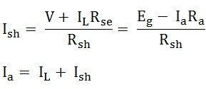

Terminal voltage is given as

compound-wound-generator-eq7If the brush contact drop is included, the terminal voltage equation is written as

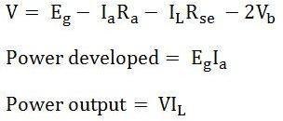In this type of DC generator, the field is produced by the shunt as well as series winding. The shunt field is stronger than the series field. If the magnetic flux produced by the series winding assists the flux produced by the shunt field winding, the generator is said to be Cumulatively Compound Wound generator.

If the series field flux opposes the shunt field flux, the generator is said to be Differentially Compounded.

# Voltage buildup in self excited Generator or Dc Shunt Generato

A self-excited DC generator supplies its own field excitation. A self-excited generator shown in figure is known as a shunt generator because its field winding is connected in parallel with the armature. Thus, the armature voltage supplies the field current.

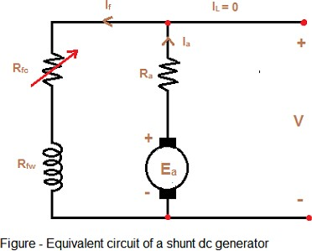

This generator will build up a desired terminal voltage. Assume that the generator in figure has no load connected to it and armature is driven at a certain speed by a prime mover. we shall study the condition under which the voltage buildup takes place. Due to this residual flux, a small voltage Ear will be generated. It is given by

https://1.bp.blogspot.com/-1XMfD31Jhj8/WRr5qEdQ_iI/AAAAAAAAAsE/OVPfhkC0AX0_if2oMWTWuOweGMkbIsVTwCLcB/s1600/ggggg.png

https://3.bp.blogspot.com/-TrCGmsVeWv8/WRr8IkfaN0I/AAAAAAAAAsc/TnhGfJJd9mwcZPGOyX74gZQP28JuTLO0gCLcB/s1600/ttt.pngThis voltage is of the order of 1V or 2V . It causes a current If to flow in the field winding in the generator. The field current is given by

This field current produces a magneto motive force in the field winding, which increases the flux. This increase in flux increases the generated voltage Ea. The increased armature voltage Ea increases the terminal voltage V. with the increase in V, the field current Ifincreases further. This in turn increases Φ and consequently Ea increases further. The process of the voltage buildup continues. Figure shows the voltage buildup of a dc shunt generator.

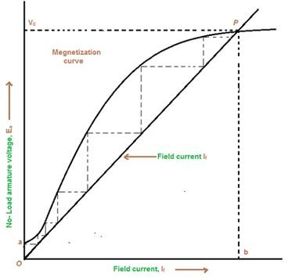

OCC Characteristics of DC generator

The effect of magnetic saturation in the pole faces limits the terminal voltage of the generator to a steady state value.

https://1.bp.blogspot.com/-PjCdKrzi2CU/WRsdRBHZlOI/AAAAAAAAAs8/XNz8ZCGUl403f8I5dEvYoVJFZhHYn-FeQCLcB/s1600/ee.pngWe have assumed that the generator is no load during the buildup process. The following equations describe the steady state operation.

Since the field current If in a shunt generator is very small, the voltage drop If Ra can be neglected, and V=Ea

The Ea versus If curve is the magnetization curve shown in figure for the field circuit V = If Rf

The straight line given by V = If Rf is called the **field-resistance line**.

The field resistance line is a plot of the voltage If Rf across the field circuit versus the field If. The slop this line is equal to the resistance of the field circuit.

The no-load terminal voltage V0 of thr generator. thus, the intersection point *P* of the magnetization curve and the field resistance line gives the no-load terminal voltage V0(*bP*) and the corresponding field current (*Ob*). Normally, in the shunt generator the voltage buildup to the value given by the point *P*. at this point Ea = If Rf = V0.

If the field current corresponding to point P is increase further, there is no further increase in the terminal voltage.

The no-load voltage is adjusted by adding resistance in series with shunt field. This increase slope of this line causing the operating point to shift at lower voltage

The operating point are graphical solution of two simultaneous equation namely, the magnetization curve and field resistance line. A graphical solution is preferred due to non-linear nature of magnetization curve.

Self-excited generator is designed to obtain no-load voltage from 50% to 125% of the rated value while varying the added resistance in field circuit from maximum to zero value.

# Critical Field Resistance:

Figure below shows the voltage buildup in the dc shunt generator for various resistances of the field circuit.

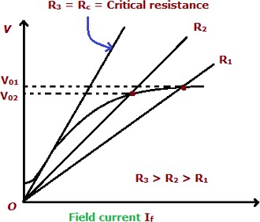

Fig: Determination of critical resistance

A decrease in the resistance of the field circuit reduces the slope of the field resistance line result in higher voltage. If the speed remains constant, an increase in the resistance of field circuit increases the slop of field resistance line, resulting in a lower voltage. If the field circuit resistance is increased to Rc which is terminal as the critical resistance of the field, the field resistance line becomes a tangent to the initial part of the magnetization curve. When the field resistance is higher than this value, the generator fails to excite.

# Critical Speed:

Figure shows the variation of no-load voltage with fixed Rf and variable speed of the armature.

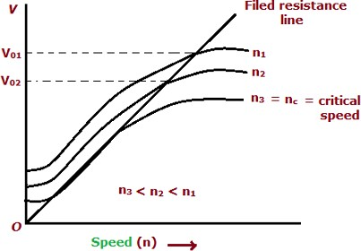

Fig: Determination of critical speed

The magnetization curve varies with the speed and its ordinate for any field current is proportional to the speed of the generator. all the points on the magnetization curve are lowered, and the point of intersection of the magnetization curve and the field resistance line moves downwards. at a particular speed, called the critical speed, the field resistance line becomes tangential to the magnetization curve. below the critical speed the voltage will not build up.

In Brief, the following condition must be satisfied for voltage buildup in a self-excited generator. There must be sufficient residual flux in the field poles.

* 1. the field terminal should be connected such a way that the field current increases flux in the direction of residual flux.
  2. The field circuit resistance should be less than the critical field circuit resistance.

If there is a no residual flux in the field poles, Disconnected the field from the armature circuit and apply a dc voltage to the field winding. this process is called Flashing the field. It will induce some residual flux in the field poles.

# Causes for Failure to Self-Excite and Remedial Measures

There may be one or more of the following reasons due which a self-excited generator may fail to build up voltage.

### No residual magnetism

The start of the buildup process needs some residual magnetism in the magnetic circuit of the generator. If there is little or no residual magnetism. because of inactivity or jarring in shipment, no voltage will be induced that can produce field current.

### Reversal of Field Connections

The voltage induced owing to residual magnetism acts across the field and results in flow or current in the field coils in such a direction as to produce magnetic flux in the same direction as the residual flux.

Reversal of connections of the field winding destroys the residual magnetism which causes the generator failure to build up voltage.

### In case of dc series wound generators

The resistance in the load circuit may be more than its critical resistance, which may be due to

* 1. open-circuit
  2. high resistance of load circuit
  3. faulty contact between brushes and commutator and
  4. commutator surface dirty or greasy.

### In case of shunt wound generator

1. the resistance of the shunt field circuit may be greater than the critical resistance;
2. the resistance in the load circuit may be lower than the critical resistance;
3. the speed of rotation may not be equal to rated one.

### Remedy

In case the generator is started up for the first time, it may be that no voltage will be built up either because the poles have no residual magnetism or the poles have retained some residual magnetism but the field winding connections are reversed so that the magnetism developed by the field winding on start has destroyed the residual magnetism and the machine can not "build up". In both the cases, the field coils must be connected to a dc source (a storage battery) for a short while to magnetize the poles. The application of external source of direct current to the field is called flashing of the field.

Characteristics of DC Generators

Generally, following three characteristics of DC generators are taken into considerations: (i) Open Circuit Characteristic (O.C.C.), (ii) Internal or Total Characteristic and (iii) External Characteristic. These characteristics of DC generators are explained below.

### Open Circuit Characteristic (O.C.C.) (E0/If)

Open circuit characteristic is also known as magnetic characteristic or no-load saturation characteristic. This characteristic shows the relation between generated emf at no load (E0) and the field current (If) at a given fixed speed. The O.C.C. curve is just the magnetization curve and it is practically similar for all type of generators. The data for O.C.C. curve is obtained by operating the generator at no load and keeping a constant speed. Field current is gradually increased and the corresponding terminal voltage is recorded. The connection arrangement to obtain O.C.C. curve is as shown in the figure below. For shunt or series excited generators, the field winding is disconnected from the machine and connected across an external supply.

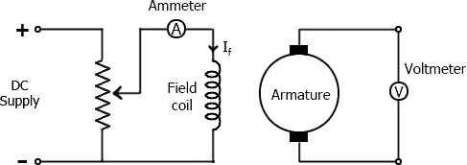

Fig: Circuit for OCC

Now, from the [emf equation of dc generator,](http://www.electricaleasy.com/2012/12/emf-and-torque-equation-of-dc-machine.html) we know that Eg = kɸ. Hence, the generated emf should be directly proportional to field flux (and hence, also directly proportional to the field current). However, even when the field current is zero, some amount of emf is generated (represented by OA in the figure below). This initially induced emf is due to the fact that there exists some residual magnetism in the field poles. Due to the residual magnetism, a small initial emf is induced in the armature. This initially induced emf aids the existing residual flux, and hence, increasing the overall field flux. This consequently increases the induced emf. Thus, O.C.C. follows a straight line. However, as the flux density increases, the poles get saturated and the ɸ becomes practically constant. Thus, even we increase the If further, ɸ remains constant and hence, Eg also remains constant. Hence, the O.C.C. curve looks like the B-H characteristic.

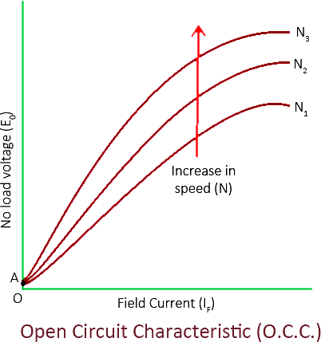

The above figure shows a typical no-load saturation curve or open circuit characteristics for all types of DC generators.

### Internal or Total Characteristic (E/Ia)

An internal characteristic curve shows the relation between the on-load generated emf (Eg) and the armature current (Ia). The on-load generated emf Eg is always less than E0 due to the [armature reaction](http://www.electricaleasy.com/2013/01/armature-reaction-in-dc-machines.html). Eg can be determined by subtracting the drop due to demagnetizing effect of armature reaction from no- load voltage E0. Therefore, internal characteristic curve lies below the O.C.C. curve.

### External Characteristic (V/IL)

An external characteristic curve shows the relation between terminal voltage (V) and the load current (IL). Terminal voltage V is less than the generated emf Eg due to voltage drop in the armature circuit. Therefore, external characteristic curve lies below the internal characteristic curve. External characteristics are very important to determine the suitability of a generator for a given purpose. Therefore, this type of characteristic is sometimes also called as performance characteristic or load characteristic.

Internal and external characteristic curves are shown below for each [type of generator](http://www.electricaleasy.com/2012/12/classifications-of-dc-machines.html).

### DC MOTORS

### WORKING PRINCIPLE OF A DC MOTOR

The DC motor is the device which converts the direct current into the mechanical work. It works on the principle of Lorentz Law, which states that “the current carrying conductor placed in a magnetic and electric field experience a force”. And that force is called the Lorentz force. The Fleming left-hand rule gives the direction of the force.

### Fleming Left Hand Rule

If the thumb, middle finger and the index finger of the left hand are displaced from each other by an angle of 90°, the middle finger represents the direction of the magnetic field. The index finger represents the direction of the current, and the thumb shows the direction of forces acting on the conductor.

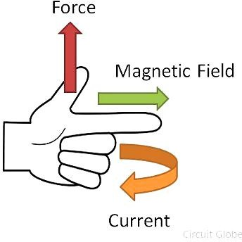

Fig: Flemings left hand rule The formula calculates the magnitude of the force,

working-principle-of-dc-motor-eqBefore understanding the working of DC motor first, we have to know about their construction. The armature and stator are the two main parts of the DC motor. The armature is the rotating part, and the stator is their stationary part. The armature coil is connected to the DC supply.

The armature coil consists the commutators and brushes. The commutators convert the AC induces in the armature into DC and brushes transfer the current from rotating part of the motor to the stationary external load. The armature is placed between the north and south pole of the permanent or electromagnet.

For simplicity, consider that the armature has only one coil which is placed between the magnetic field shown below in the figure A. When the DC supply is given to the armature coil the current starts flowing through it. This current develops their own field around the coil. Figure B shows the field induces around the coil.

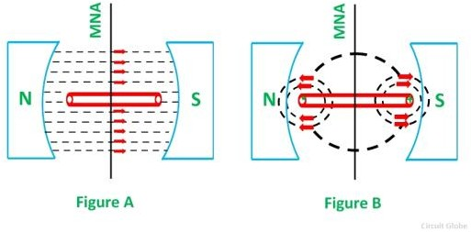

Fig: magnetic field induces around the coil.

By the interaction of the fields (produces by the coil and the magnet), resultant field develops across the conductor. The resultant field tends to regain its original position, i.e. in the axis of the main field. The field exerts the force at the ends of the conductor, and thus the coil starts rotating.

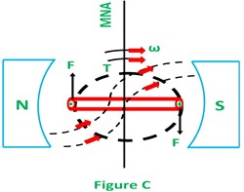

Fig: Field produced due to poles alone

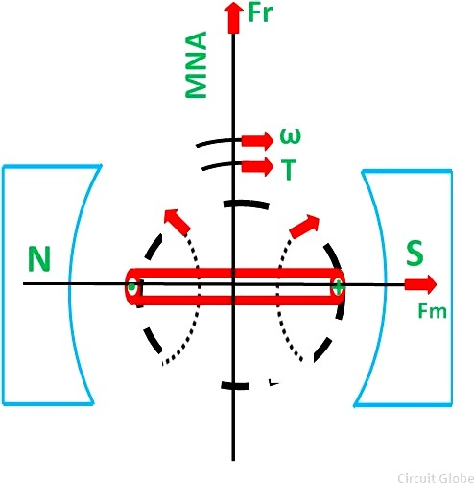Let the field produces by the main field be Fm, and this field rotates in the clockwise direction. When the current flows in the coil, they produce their own magnetic field says Fr. The field Fr tries to come in the direction of the main field. Thereby, the torque act on the armature coil.

Fig: Field produced due to conductors alone

The actual DC motor consists a large number of armature coils. The speed of the motor is directly proportional to the number of coils used in the motor. These coils are kept under the impact of the magnetic field.

The one end of the conductors are kept under the influence of north pole, and the other end is kept under the influence of the South pole. The current enters into the armature coil through the north pole and move outwards through the south pole. When the coil moves from one brush to another, at the same time the polarity of the coil also changes. Thus, the direction of the force or torque acting on the coil remains same.

The torque induces in the coil become zero when the armature coil is perpendicular to the main field. The zero torque means the motor stops rotating. For solving this problem, the number of armature coil is used in the rotor. So if one of their coils is perpendicular to the field, then the other coils induce the torque. And the rotor moves continuously.

Also, for obtaining the continuous torque, the arrangement is kept in such a way that whenever the coils cut the magnetic neutral axis of the magnet the direction of current in the coils become reversed. This can be done with the help of the commutator.

**Back Emf and its Significance in DC Motor**

When a dc voltage V is applied across the motor terminals, the armature starts rotating due to the torque developed in it.

As the armature rotates, armature conductors cut the pole magnetic field, therefore, as per law of electromagnetic induction, an emf called ***back emf*** is induced in them.

The back emf (also called counter emf) is given by

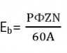where, P=number of poles of dc motor Φ= flux per pole

Z=total number of armature conductors N=armature speed

A=number of parallel paths in armature winding

As all other parameters are constant, therefore, Eb ∝ N

As per Lenz's law, "the induced emf always opposes the cause of its production”. Here, the cause of generation of back emf is the rotation of armature. Rotation of armature is due to armature torque. Torque is due to armature current and armature current is due to supply dc voltage V. Therefore, the ultimate cause of production of Eb is the supply voltage V.

### Therefore, back emf is always directed opposite to supply voltage V.

**Significance of back emf in dc motor**

1. As the back emf opposes supply voltage V, therefore, supply voltage has to force current through the armature against the back emf, to keep armature rotating. The electric work done in overcoming and causing the current to flow against the back emf is converted into mechanical energy developed in the armature.

It follows, therefore, that energy conversion in a dc motor is only possible due to the production of back emf.

Mechanical power developed in the armature = EbIa

1. Back emf makes dc motor a self-regulating motor i.e Eb makes motor to adjust Ia automatically as per the load torque requirement. Lets see how.

From the motor figure,

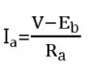V and Ra are fixed, therefore, armature current Ia dpends on back emf, which in turn depends on speed of the motor.

1. when the motor is running at no-load, small torque ( Ta=KIa ) is required by the motor to overcome friction and windage. Therefore, a small current is drawn by the motor armature and the back emf is almost equal to the supply voltage.
2. If the motor is suddenly loaded, the load torque beomes greater than the armature torque and the motor starts to slow down. As motor speed decreases, back emf decreases and therefore, armature current starts increasing. With increasing Ia , armature torque increases and at some point it becomes equal to the load torque. At that moment, motor stops slowing down and keeps running at this new speed.
3. If the load on the motor is suddenly reduced, the driving torque becomes more than the load torque and the motor starts accelerating. As the motor speed increases, back emf increases and therefore, armature current decreases. Due to this reducing armature current, armature developed torque decreases and at some point becomes equal to the load torque. That point onwards, motor will stop accelerating and will start rotating uniformly at this new slightly increased speed.

So, this shows how important is back emf in dc motor. Without back emf, the electromagnetic energy conversion would not have been possible at the first place.

**Power Equation of a D.C. Motor**

The voltage equation of a d.c. motor is given by,

V = Eb + Ia Ra Multiplying both sides of the above equation by Ia we get,

Ia = Eb Ia + Ia 2 Ra This equation is called power equation of a d.c. motor.

VIa = Net electrical power input to the armature measured in watts.

Ia2Ra = Power loss due the resistance of the armature called armature copper loss.

So difference between VIa and Ia2Ra i.e. input - losses gives the output of the armature.

So Eb Ia is called electrical equivalent of gross mechanical power developed by the armature.

This is denoted as Pm.

... Power input to the armature - Armature copper loss = Gross mechanical power developed in the armature.

**Condition for Maximum Power**

For a motor from power equation it is known that, Pm = Gross mechanical power developed = Eb Ia

= VIa - Ia2Ra

For maximum Pm, dPm/dIa = 0

... 0 = V - 2IaRa

... Ia = V/2Ra i.e. IaRa = V/2 Substituting in voltage equation,

V = Eb + IaRa = Eb + (V/2)

... Eb = V/2 Condition for maximum power

Key Point : This is practically impossible to achieve as for this, current required is much more than its normal rated value. Large heat will be produced and efficiency of motor will be less than 50 %.

# TORQUE EQUATION OF A DC MOTOR

When a DC machine is loaded either as a motor or as a generator, the rotor conductors carry current. These conductors lie in the magnetic field of the air gap. Thus, each conductor experiences a force. The conductors lie near the surface of the rotor at a common radius from its centre. Hence, a torque is produced around the circumference of the rotor, and the rotor starts rotating.

When the machine operates as a generator at a constant speed, this torque is equal and opposite to that provided by the prime mover. When the machine is operating as a motor, the torque is transferred to the shaft of the rotor and drives the mechanical load. The expression is same for the generator and motor.

When the current carrying current is placed in the magnetic field, a force is exerted or it which exerts turning moment or torque F x r.

This torque is produced due to the electromagnetic effect, hence is called **Electromagnetic torque.** The torque which is produced in the armature is not fully used at the shaft for doing the useful work. Some part of it where lost due to mechanical losses. The torque which is used for doing useful work in known as the shaft torque.

Since,

torque-equation-of-dc-motor-eq1Multiplying the equation (1) by Ia we get

torque-equation-of-dc-motor-eq2Where,

VIa is the electrical power input to the armature. I2 R is the copper loss in the armature.

a a

We know that,

### Total electrical power supplied to the armature = Mechanical power developed by the armature + losses due to armature resistance

Now, the mechanical power developed by the armature is Pm.

torque-equation-of-dc-motor-eq4torque-equation-of-dc-motor-eq3Also, the mechanical power rotating armature can be given regarding torque T and speed n.

Where n is in revolution per seconds (rps) and T is in Newton-Meter. Hence,

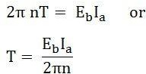But,

torque-equation-of-dc-motor-eq6

Where N is the speed in revolution per minute (rpm) and

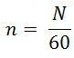Where, n is the speed in (rps).

Therefore,

torque-equation-of-dc-motor-eq8So, the torque equation is given as

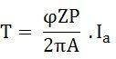For a particular DC Motor, the number of poles (P) and the number of conductors per parallel path (Z/A) are constant.

torque-equation-of-dc-motor-eq10Where,

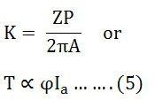Thus, from the above equation (5) it is clear that the torque produced in the armature is directly proportional to the flux per pole and the armature current. Moreover, the direction of electromagnetic torque developed in the armature depends upon the current in armature conductors. If either of the two is reversed the direction of torque produced is reversed and hence the direction of rotation. But when both are reversed, and direction of torque does not change.

# Shaft Torque

In a DC Motor whole of the electromagnetic torque (T) developed in the armature is not available on the shaft. A part of it is lost to overcome the iron and mechanical (friction and windage) losses. Therefore, shaft torque (Tsh) is somewhat less than the torque developed in the armature.

**Definition:** Thus, in the case of DC motors, the actual torque available at the shaft for doing useful mechanical work is known as **Shaft Torque.** It is so called because it is available on the shaft of the motor. It is represented by the symbol Tsh. The output of the motor is given by the equation shown below where Tsh is the shaft torque in r.p.s and the N is the rotation of the motor in r.p.m. The shaft torque is expressed as



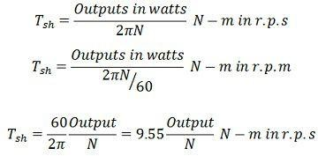

The difference between the armature torque and the shaft torque ( Ta – Tsh ) is known as the lost torque and is due to the formation of the torque.

### Brake Horse Power (B.H.P)

In the case of the motor, the mechanical power available at the shaft is known as Brake Horse Power. If Tsh is the shaft torque in Newton Meter and N is the speed in r.p.m then,

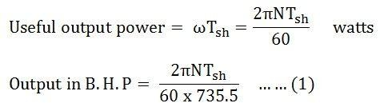

The output brake horsepower is given by the equation (1) shown above.

# TYPES OF DC MOTOR

A Direct Current Motor, DC is named according to the connection of the field winding with the armature.

Mainly there are two types of DC Motors.

1. Separately Excited DC Motor and
2. Self-excited DC Motor.
3. Shunt wound or shunt motor,
4. Series wound or series motor and
5. Compound wound or compound motor.

The dc motor converts the electrical power into mechanical power is known as dc motor. The construction of the dc motor and generator are same. But the dc motor has the wide range of speed and good speed regulation which in electric traction.

The working principle of the dc motor is based on the principle that the current carrying conductor is placed in the magnetic field and a mechanical force experience by it.

The DC motor is generally used in the location where require protective enclosure, for example, drip- proof, the fireproof, etc. according to the requirements. The detailed description of the various types of the motor is given below.

Separately Excited DC Motor

As the name signifies, the field coils or field windings are energized by a separate DC source as shown in the circuit diagram shown below.

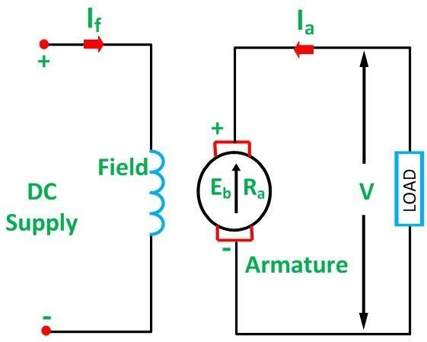

*Separately Excited DC Motor*

# Self-Excited DC Motor

As the name implies self-excited, hence, in this type of motor, the current in the windings is supplied by the machine or motor itself. Self-excited DC Motor is further divided into shunt wound, and series-wound motor. They are explained below in detail.

# Shunt Wound Motor

This is the most common types of DC Motor. Here the field winding is connected in parallel with the armature as shown in the figure below.

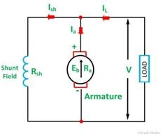Shunt Wound DC Motor

The current, voltage and power equations for a shunt motor are written as follows. By applying KCL at the junction A in the above figure.

The sum of the incoming currents at A = Sum of the outgoing currents at A.

types-of-motor-eq1Where,

I is the input line current, Ia is the armature current,

Ish is the shunt field current

Equation (1) is the current equation.

types-of-motor-eq2The voltage equations are written by using Kirchhoff’s voltage law (KVL) for the field winding circuit.

types-of-motor-eq3For armature winding circuit the equation will be given as

The power equation is given as

### types-of-motor-eq4Power input = mechanical power developed + losses in the armature + loss in the field.

Multiplying equation (3) by Ia we get the following equations.

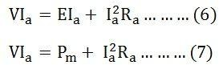

Where,

VIa is the electrical power supplied to the armature of the motor.

# Series Wound Motor

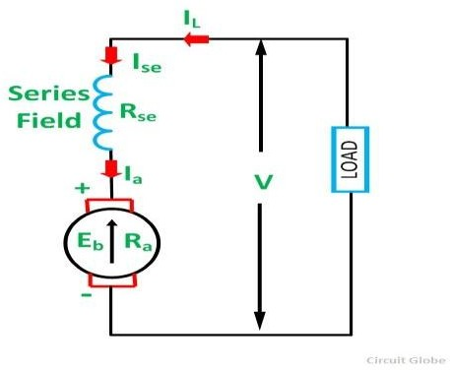In the series motor, the field winding is connected in series with the armature winding. The connection diagram is shown below.

Series Wound Motor

By applying the KCL in the above figure

types-of-motor-eq6-Where,

Ise is the series field current

The voltage equation can be obtained by applying KVL in the above figure

types-of-motor-eq7The power equation is obtained by multiplying equation (8) by I we get

types-of-motor-eq8Power input = mechanical power developed + losses in the armature + losses in the field

types-of-motor-eq9Comparing the equation (9) and (10), we will get the equation shown below.

types-of-motor-eq10

# Compound Wound Motor

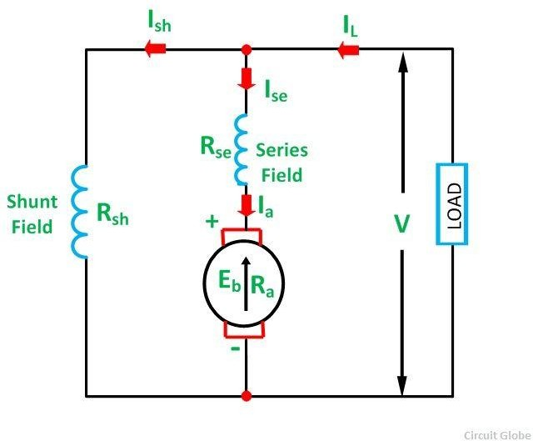A DC Motor having both shunt and series field windings is called a **Compound Motor**. The connection diagram of the compound motor is shown below.

*Compound Motor*

The compound motor is further subdivided as **Cumulative Compound** Motor and **Differential Compound** Motor. In cumulative compound motor the flux produced by both the windings is in the same direction, i.e.

types-of-motor-eq11

In differential compound motor, the flux produced by the series field windings is opposite to the flux produced by the shunt field winding, i.e.

types-of-motor-eq12The positive and negative sign indicates that direction of the flux produced in the field windings.

**CHARACTERISTICS OF DC MOTORS**

Generally, three characteristic curves are considered important for [DC motors](http://www.electricaleasy.com/2014/01/basic-working-of-dc-motor.html) which are,

1. Torque vs. armature current,
2. Speed vs. armature current and
3. Speed vs. torque.

These are explained below for each [type of DC motor.](http://www.electricaleasy.com/2012/12/classifications-of-dc-machines.html) These characteristics are determined by keeping the following two relations in mind.

### Ta ∝ ɸ.Ia and N ∝ Eb/ɸ

These above equations can be studied at - [emf and torque equation of dc machine](http://www.electricaleasy.com/2012/12/emf-and-torque-equation-of-dc-machine.html). For a DC motor, magnitude of the back emf is given by the same emf equation of a dc generator i.e. Eb = PɸNZ / 60A. For a machine, P, Z and A are constant, therefore, N ∝ Eb/ɸ

### Characteristics of DC Series Motors Torque Vs. Armature Current (Ta-Ia)

This characteristic is also known as electrical characteristic.

We know that torque is directly proportional to the product of armature current and field flux,

Ta ∝ ɸ.Ia.

In DC series motors, field winding is connected in series with the armature, i.e. Ia = If. Therefore, before magnetic saturation of the field, flux ɸ is directly proportional to Ia. Hence, before magnetic saturation

Ta α Ia2.

Therefore, the Ta-Ia curve is parabola for smaller values of Ia.

After magnetic saturation of the field poles, flux ɸ is independent of armature current Ia. Therefore, the torque varies proportionally to Ia only,

T ∝ Ia.

Therefore, after magnetic saturation, Ta-Ia curve becomes a straight line. The shaft torque (Tsh) is less than armature torque (Ta) due to [stray losses.](http://www.electricaleasy.com/2014/01/losses-in-dc-machine.html) Hence, the curve Tsh vs Ia lies slightly lower.

In DC series motors, (prior to magnetic saturation) torque increases as the square of armature current, these motors are used where high starting torque is required.

### Speed Vs. Armature Current (N-Ia)

We know the relation, N ∝ Eb/ɸ

For small load current (and hence for small armature current) change in back emf Eb is small and it may be neglected. Hence, for small currents speed is inversely proportional to ɸ. As we know, flux is directly proportional to Ia, speed is inversely proportional to Ia. Therefore, when armature current is very small the speed becomes dangerously high. That is why a series motor should never be started without some mechanical load.

But, at heavy loads, armature current Ia is large. And hence, speed is low which results in decreased back emf Eb. Due to decreased Eb, more armature current is allowed.

### Speed Vs. Torque (N-Ta)

This characteristic is also called as mechanical characteristic. From the above two characteristics of DC series motor, it can be found that when speed is high, torque is low and vice versa.

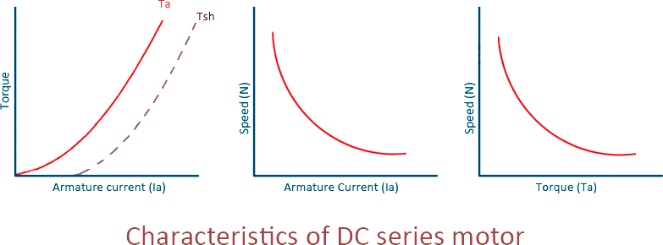

### Characteristics Of DC Shunt Motors Torque Vs. Armature Current (Ta-Ia)

In case of DC shunt motors, we can assume the field flux ɸ to be constant. Though at heavy loads, ɸ decreases in a small amount due to increased [armature reaction](http://www.electricaleasy.com/2013/01/armature-reaction-in-dc-machines.html). As we are neglecting the change in the flux ɸ, we can say that torque is proportional to armature current. Hence, the Ta-Ia characteristic for a dc shunt motor will be a straight line through the origin.

Since heavy starting load needs heavy starting current, shunt motor should never be started on a heavy load.

### Speed Vs. Armature Current (N-Ia)

As flux ɸ is assumed to be constant, we can say N ∝ Eb. But, as back emf is also almost constant, the speed should remain constant. But practically, ɸ as well as Eb decreases with increase in load. Back emf Eb decreases slightly more than ɸ, therefore, the speed decreases slightly. Generally, the speed decreases only by 5 to 15% of full load speed. Therefore, a shunt motor can be assumed as a constant speed motor. In speed vs. armature current characteristic in the following figure, the straight horizontal line represents the ideal characteristic and the actual characteristic is shown by the dotted line.

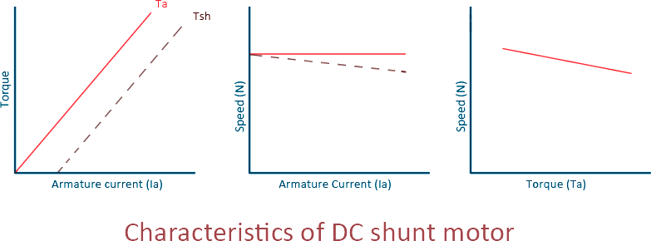

### Characteristics of DC Compound Motor

DC compound motors have both series as well as shunt winding. In a compound motor, if series and shunt windings are connected such that series flux is in direction as that of the shunt flux then the motor is said to be cumulatively compounded. And if the series flux is opposite to the direction of the shunt flux, then the motor is said to be differentially compounded. Characteristics of both these compound motors are explained below.

### Cumulative compound motor

Cumulative compound motors are used where series characteristics are required but the load is likely to be removed completely. Series winding takes care of the heavy load, whereas the shunt winding prevents the motor from running at dangerously high speed when the load is suddenly removed. These motors have generally employed a flywheel, where sudden and temporary loads are applied like in rolling mills.

### Differential compound motor

Since in differential field motors, series flux opposes shunt flux, the total flux decreases with increase in load. Due to this, the speed remains almost constant or even it may increase slightly with increase in load (N ∝ Eb/ɸ). Differential compound motors are not commonly used, but they find limited applications in experimental and research work.

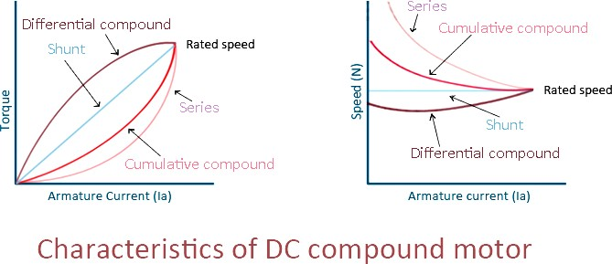

# SPEED CONTROL OF DC MOTOR:

The dc motor converts the mechanical power into dc electrical power. One of the most important features of the dc motor is that their speed can easily be control according to the requirement by using simple methods. Such type of control is impossible in an AC motor.

The concept of the speed regulation is different from the speed control. In speed regulation, the speed of the motor changes naturally whereas in dc motor the speed of the motor changes manually by the operator or by some automatic control device. The speed of the DC Motor is given by the relation shown below.

The equation (1) that the speed is dependent upon the supply voltage V, the armature circuit resistance Ra and the field flux ϕ, which is produced by the field current.

SPEED-CONTROL-OF-DC-MOTOR-EQ-1For controlling the speed of DC Motor, the variation in voltage, armature resistance and field flux is taken into consideration. There are three general methods of speed control of a DC Motor. They are as follows.

* 1. Variation of resistance in the armature circuit. This method is called Armature Resistance or Rheostatic control.
  2. Variation in field flux. This method is known as Field Flux Control.
  3. Variation in applied voltage. This method is also known as Armature Voltage Control.

The detailed discussion of the various method of controlling the speed is given below.

# Armature Resistance Control of DC Motor

### Shunt Motor

The connection diagram of a shunt motor of the armature resistance control method is shown below. In this method, a variable resistor Re is put in the armature circuit. The variation in the variable resistance does not effect the flux as the field is directly connected to the supply mains.

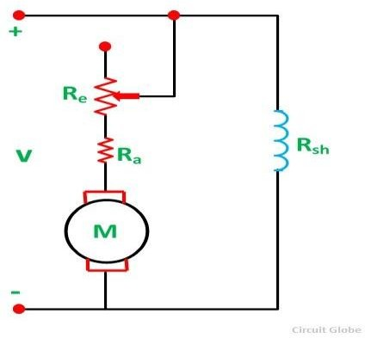

Fig: Connection diagram of a shunt motor of the armature resistance control method

The **speed current characteristic** of the shunt motor is shown below.

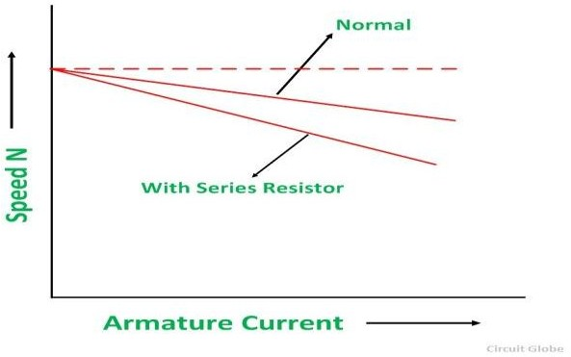

Fig: Speed current characteristic of the shunt motor

# Series Motor:

Now, let us consider a connection diagram of speed control of the DC Series motor by the armature resistance control method.

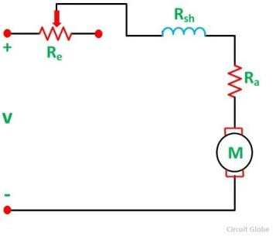Fig: Diagram of speed control of the DC Series motor

By varying the armature circuit resistance, the current and flux both are affected. The voltage drop in the variable resistance reduces the applied voltage to the armature, and as a result, the speed of the motor is reduced.

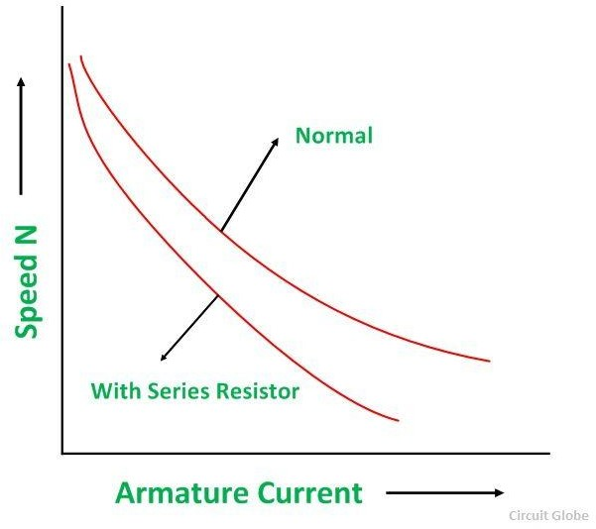The **speed–current characteristic** of a series motor is shown in the figure below.

Fig: Speed–current characteristic of a series motor

When the value of variable resistance Re is increased, the motor runs at a lower speed. Since the variable resistance carries full armature current, it must be designed to carry continuously the full armature current.

### Disadvantages of Armature Resistance Control Method

* + - A large amount of power is wasted in the external resistance Re.
    - Armature resistance control is restricted to keep the speed below the normal speed of the motor and increase in the speed above normal level is not possible by this method.
    - For a given value of variable resistance, the speed reduction is not constant but varies with the motor load.
    - This speed control method is used only for small motors.

# Field Flux Control Method of DC Motor

Flux is produced by the field current. Thus, the speed control by this method is achieved by control of the field current.

### Shunt Motor

In a Shunt Motor, the variable resistor RC is connected in series with the shunt field windings as shown in the figure below. This resistor RC is known as a **Shunt Field Regulator.**

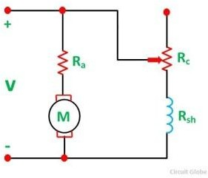Fig: Shunt Field Regulator

The shunt field current is given by the equation shown below.

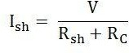

The connection of RC in the field reduces the field current, and hence the flux is also reduced. This reduction in flux increases the speed, and thus, the motor runs at speed higher than the normal speed. Therefore, this method is used to give motor speed above normal or to correct the fall of speed because of the load.

The **speed-torque curve** for shunt motor is shown below.

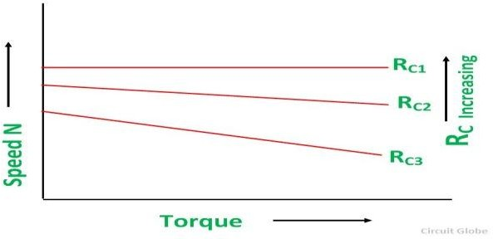

Fig: speed-torque curve for shunt motor

# Series Motor

In a series motor, the variation in field current is done by any one method, i.e. either by a diverter or by a tapped field control.

# By Using a Diverter:

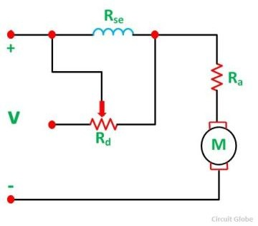A variable resistance Rd is connected in parallel with the series field windings as shown in the figure below.

Fig: Diverter is connected in parallel with the series field windings

The parallel resistor is called a Diverter. A portion of the main current is diverted through a variable resistance Rd. Thus, the function of a diverter is to reduce the current flowing through the field winding. The reduction in field current reduces the amount of flux and as a result the speed of the motor increases.

# Tapped Field Control:

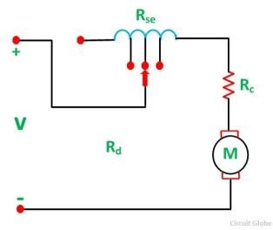The second method used in a series motor for the variation in field current is by tapped field control. The connection diagram is shown below.

Fig: Tapped Field Control

Here the ampere turns are varied by varying the number of field turns. This type of arrangement is used in an electric traction system. The speed of the motor is controlled by the variation of the field flux. The speed-torque characteristic of a series motor is shown below.

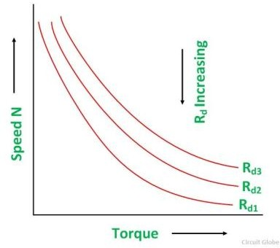Fig: Speed-torque characteristic

# Advantages of Field Flux Control

The following are the advantages of the field flux control method.

* + - This method is easy and convenient.
    - As the shunt field is very small, the power loss in the shunt field is also small.

The flux cannot usually be increased beyond its normal values because of the saturation of the iron. Therefore, speed control by flux is limited to the weakening of the field, which gives an increase in speed. This method is applicable over only to a limited range because if the field is weakened too much, there is a loss of stability.

**Armature Voltage Control of DC Motor**

In armature voltage control method the speed control is achieved by varying the applied voltage in the armature winding of the motor. This speed control method is also known as **Ward Leonard Method**, which is discussed in detail under the topic Ward Leonard Method or Armature Voltage Control.

### Ward Leonard Method Of Speed Control Or Armature Voltage Control

**Ward Leonard Method** of speed control is achieved by varying the applied voltage to the armature. This method was introduced in 1891. The connection diagram of the Ward Leonard method of speed control of a DC shunt motor is shown in the figure below.

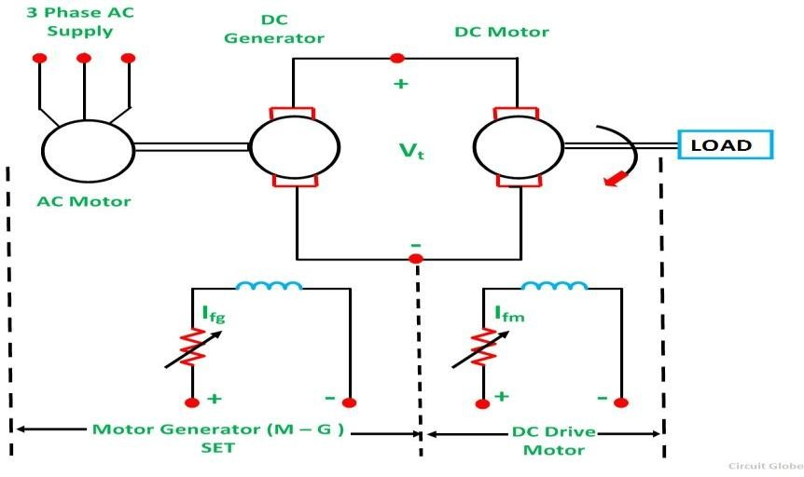

In the above system, M is the main DC motor whose speed is to be controlled, and G is a separately excited DC generator.The generator G is driven by a 3 phase driving motor which may be an induction motor or a synchronous motor. The combination of AC driving motor and the DC generator is called the **Motor-Generator (M-G) set.**

The voltage of the generator is changed by changing the generator field current. This voltage when directly applied to the armature of the main DC motor, the speed of the motor M changes. The motor field current Ifm is kept constant so that the motor field flux ϕm also remains constant. While the speed of the motor is controlled, the motor armature current Ia is kept equal to its rated value.

The generated field current Ifg is varied such that the armature voltage Vtchanges from zero to its rated value. The speed will change from zero to the base speed. Since the speed control is carried out with therated current Ia and with the constant motor field flux, a constant torque is directly proportional to the armature current, and field flux up to rated speed is obtained. The product of torque and speed is known as power, and it is proportional to speed. Thus, with the increase in power, speed increases automatically.

The **Torque and Power Characteristic** is shown in the figure below.

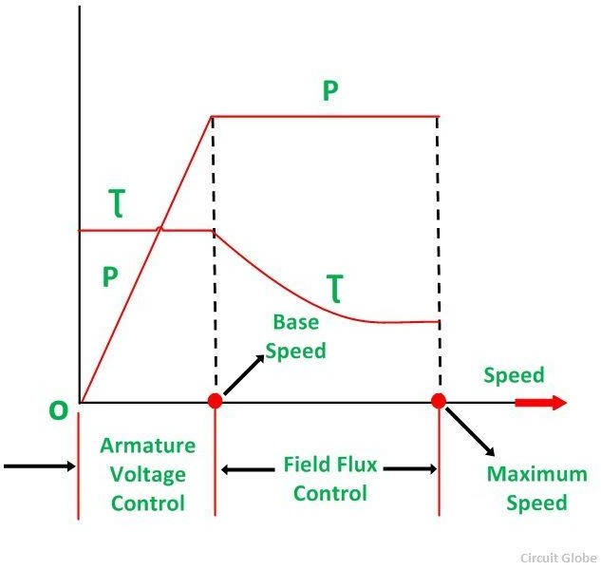

Hence, with the armature voltage control method, constant torque and variable power drive is obtained from speed below the base speed. The Field flux control method is used when the speed is above the base speed. In this mode of operation, the armature current is maintained constant at its rated value, and the generator voltage Vt is kept constant.

The motor field current is decreased and as a result, the motor field flux also decreases.This means that the field is weakened to obtain the higher speed. Since VtIa and EIa remain constant, the electromagnetic torque is directly proportional to the field flux ϕm and the armature current Ia. Thus, if the field flux of the motor is decreased the torque decreases.

Therefore, the torque decreases, as the speed increases. Thus, in the field control mode, constant power and variable torque are obtained for speeds above the base speed. When the speed control over a wide range is required, a combination of armature voltage control and field flux control is used. This combination permits the ratio of maximum to minimum speed available speeds to be 20 to 40. For closed loop control, this range can be extended up to 200.

The driving motor can be an induction or synchronous motor. An induction motor operates at a lagging power factor. The synchronous motor may be operated at a leading power factor by over-excitation of its field. Leading reactive power is generated by over excited synchronous motor. It compensates for the lagging reactive power taken by other inductive loads. Thus, the power factor is improved.

A Slip ring induction motor is used as p prime mover when the load is heavy and intermittent. A flywheel is mounted on the shaft of the motor. This scheme is known as Ward Leonard-Ilgener scheme. It prevents heavy fluctuations in supply current.

When the Synchronous motor is acting as a driving motor, the fluctuations cannot be reduced by mounting a flywheel on its shaft, because the synchronous motor always operates at a constant speed. In another form of Ward Leonard drive, non-electrical prime movers can also be used to drive the DC generator.

For example – In DC electric locomotive, DC generator is driven by a diesel engine or a gas turbine and ship propulsion drives. In this system, Regenerative braking is not possible because energy cannot flow in the reverse direction in the prime mover.

**Advantages of Ward Leonard Drives**

The main advantages of the Ward Leonard drive are as follows:-

* Smooth speed control of DC motor over a wide range in both the direction is possible.
* It has an inherent braking capacity.
* The lagging reactive volt-amperes are compensated by using an overexcited synchronous motor as the drive and thus, the overall power factor improves.
* When the load is intermittent as in rolling mills, the drive motor is an induction motor with a flywheel mounted to smooth out the intermittent loading to a low value.

### Drawbacks of Classical Ward Leonard System

The Ward Leonard system with rotating Motor Generator sets has following drawbacks.

* The Initial cost of the system is high as there is a motor generator set installed, of the same rating as that of the main DC motor.
* Larger size and weight.
* Requires large floor area
* Costly foundation
* Maintenance of the system is frequent.
* Higher losses.
* Lower efficiency.
* The drive produces more noise.

### Applications of Ward Leonard Drives

The Ward Leonard drives are used where a smooth speed control of the DC motors over a wide range in both the directions is required. Some of the examples are as follows:-

* Rolling mills
* Elevators
* Cranes
* Paper mills
* Diesel-electric locomotives
* Mine hoists